**Letter to Suzi Gablik:**

**Simon Whitehead**

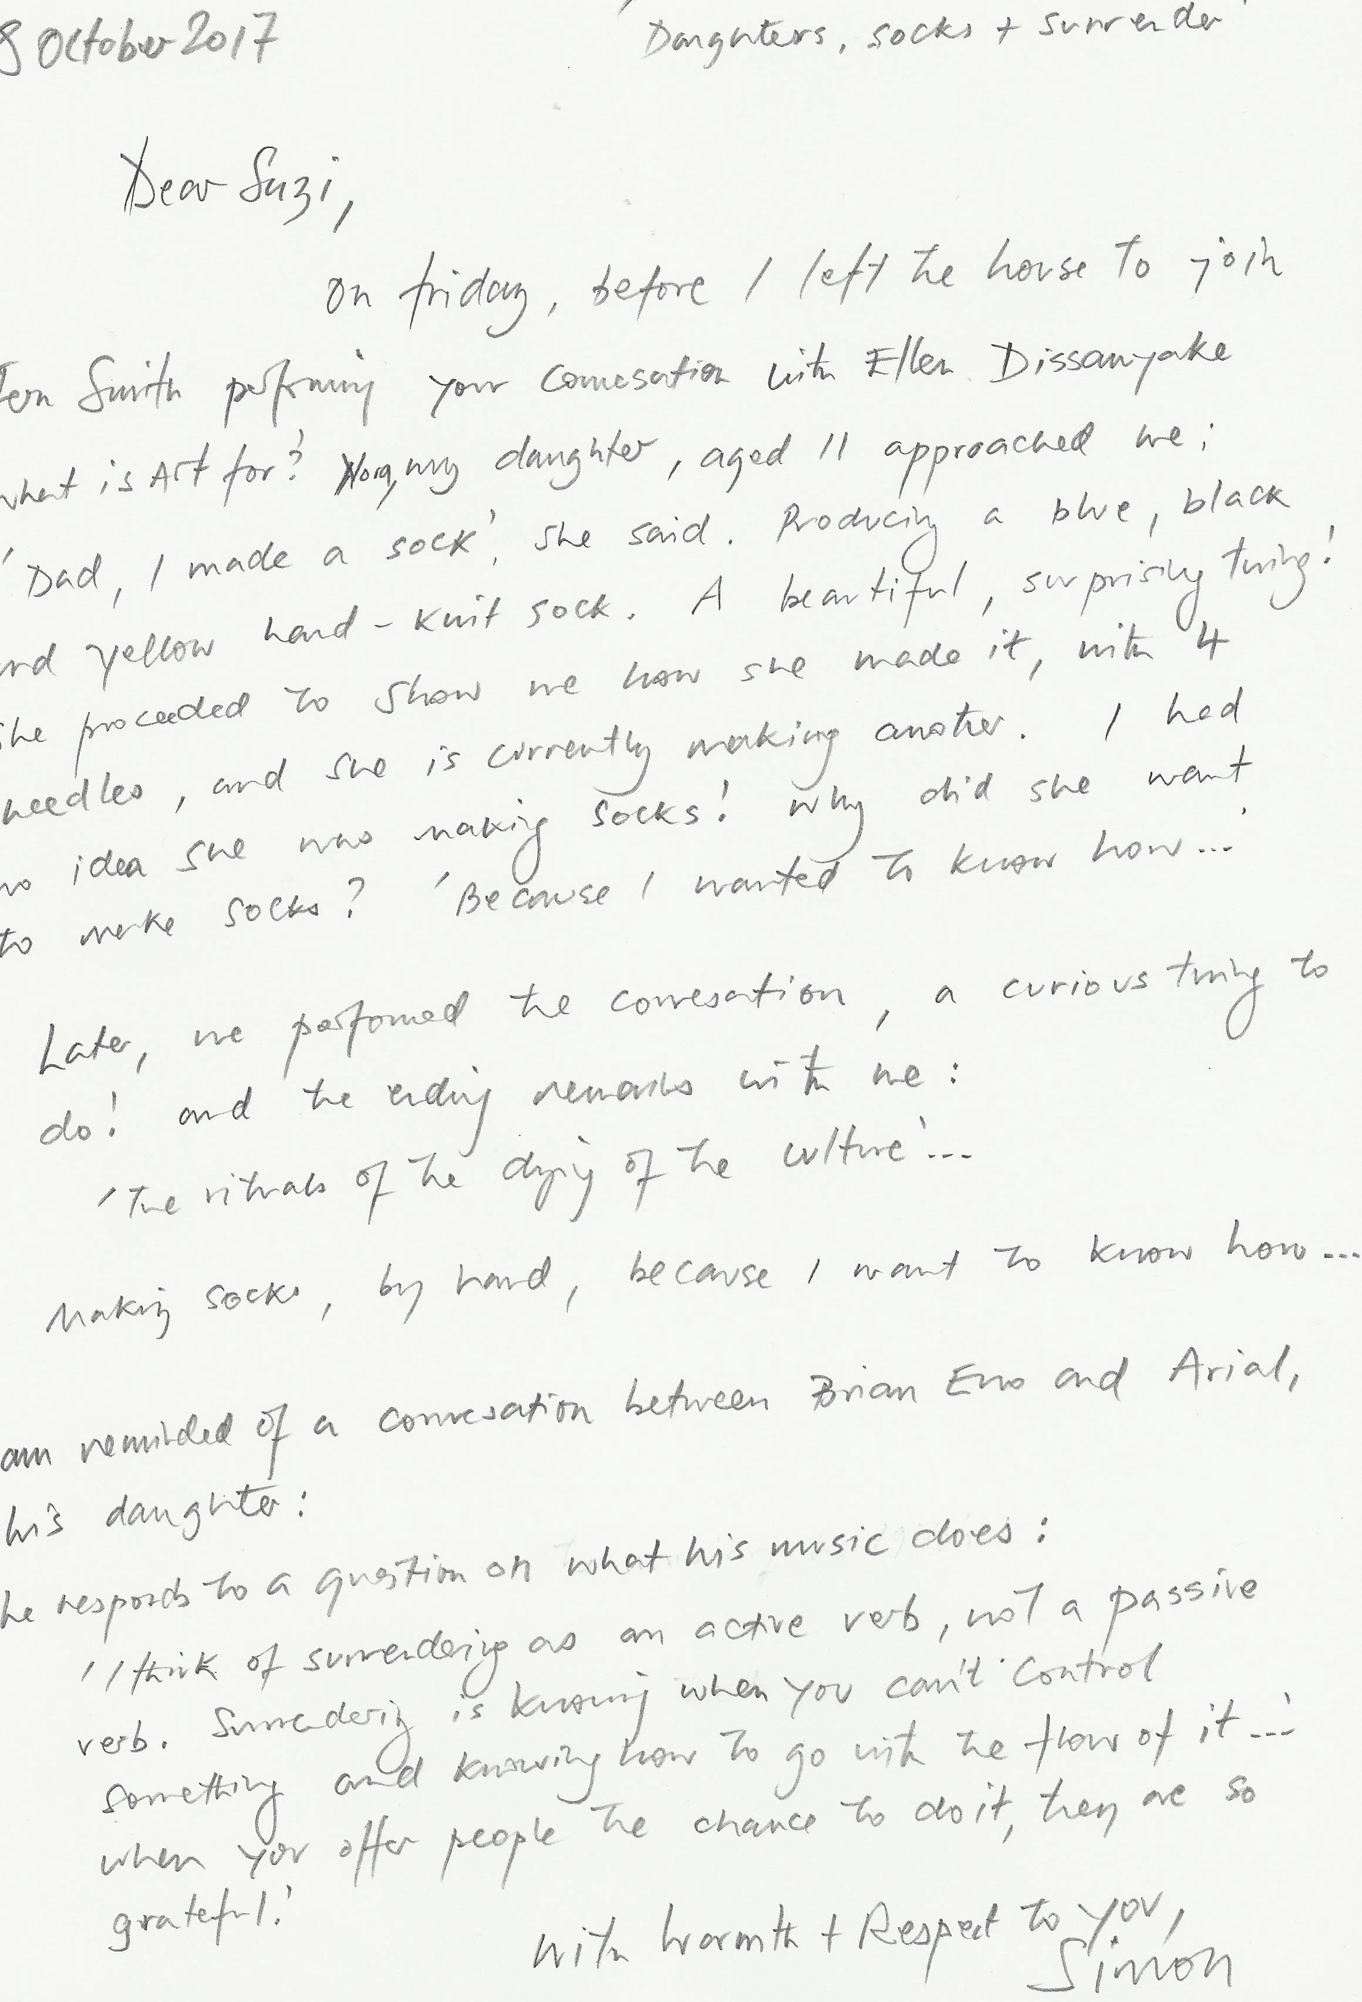

***Simon Whitehead is a movement artist and director of Maynard.***